

**Ain Shams University**

**Faculty of Engineering**

**Computer and Systems Department**

**Operating Systems**

***The Scheduler Assignment Manual***

|  |  |  |
| --- | --- | --- |
|  | **جاسر سامى عبد الهادى** | **الاسم** |
|  | **1** | **الفصل** |

**FCFS Scheduling (First come First served)**

**SJF Scheduling (Shortest Job First) Preemptive and non-preemptive**

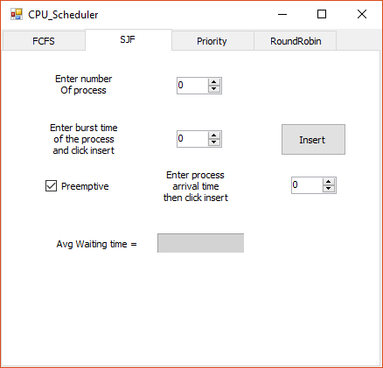**Steps to use**

**Incase non-preemptive**

* Choose SJF Tap
* Enter number of process
* Enter burst time of each process and click insert after each one.

**Incase Preemptive**

The same steps as non-preemptive but check the Preemptive check box then enter arrival time of   
each process then click insert after each one.

**Note: If you change number of process you can restart again the process.**

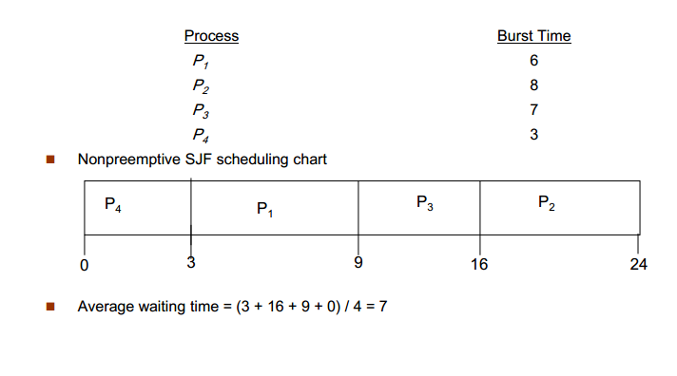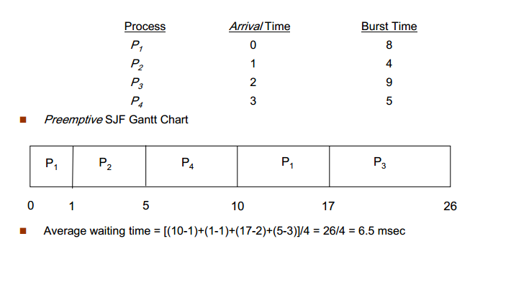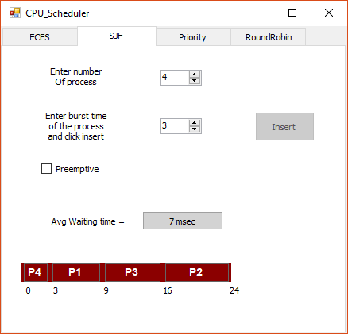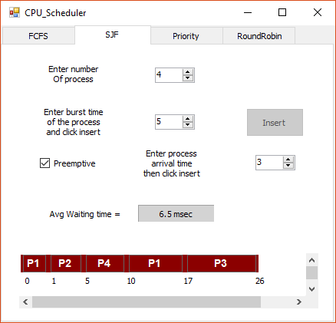

**Priority Scheduling - Preemptive and non-preemptive**

**Steps to use**

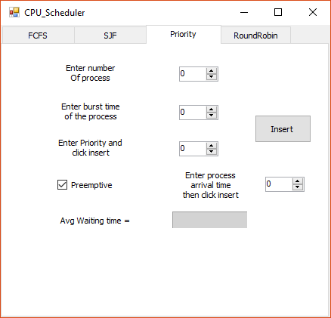

**Incase non-preemptive**

* Choose SJF Tap
* Enter number of process
* Enter burst time of each process
* Enter Priority of each process and click insert after each one.

**Incase Preemptive**

The same steps as non-preemptive but check the Preemptive check box then enter arrival time of   
each process then click insert after each one.

**Note: If you change number of process you can restart again the process.**

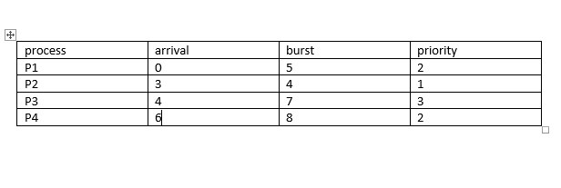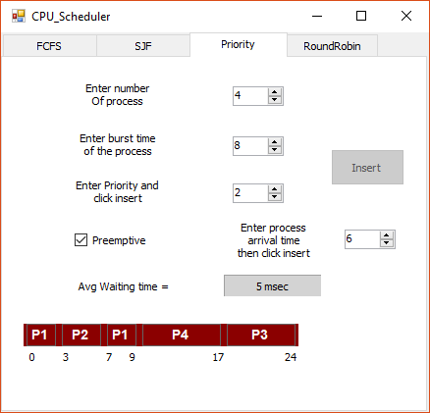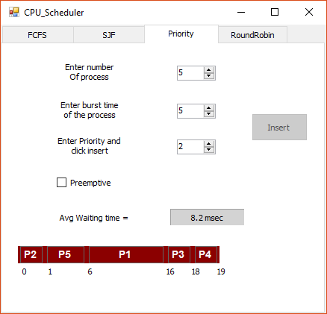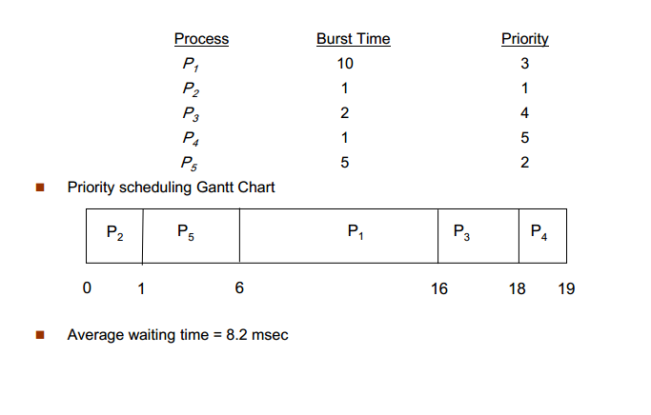

**RR Scheduling (Round Robin)**